9 – ReactJS-HOL
Step 1: Declaring an array of 11 Players and Render using map
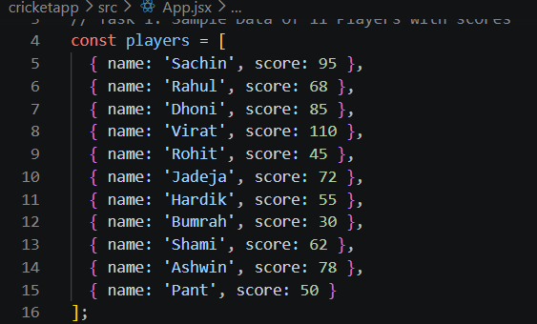
Step 2: Filtering Players with Scores Less Than 70
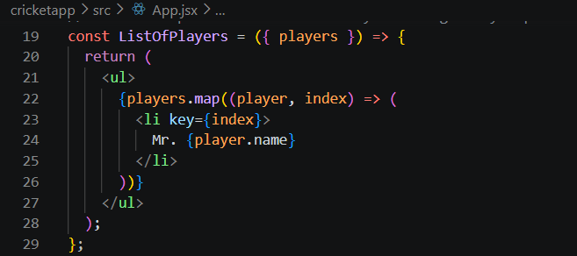
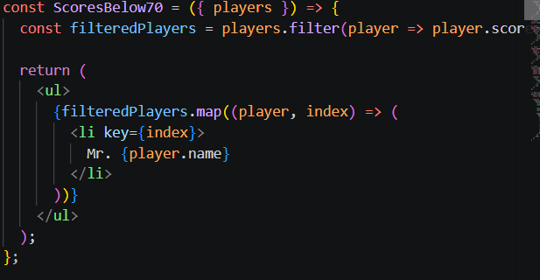
Step 3: Array De-structuring for Odd and Even Players
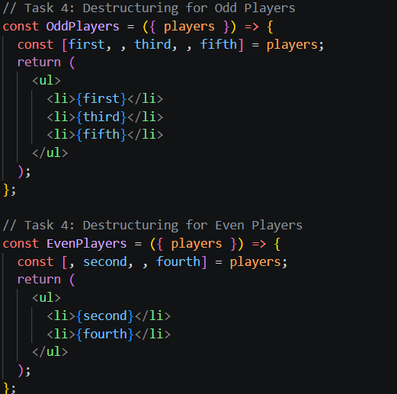
Step 4: Merging Arrays with the Spread Operator
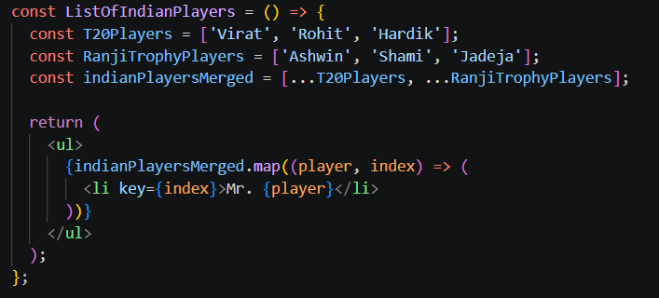

Code Output:
